**Year 12 Physics TEST # 4 – Waves and Quantum Theory 2022**

NAME:

*Total Marks: 35 Time Allowed: 45 minutes*

(Formula sheet and scientific calculator permitted)

**Question 1 (5 marks)**

1. An electron in an atom of fluorescent coral releases green light of wavelength 552 nm when it returns to ground state. Calculate the energy difference in eV involved in this transition. [4]
2. Briefly explain how phosphorescence is different from fluorescence. [1]

**Question 2 (4 marks)**

The diagram below shows two first-order spectra on a screen, which have been produced by passing white light through a single slit.



1. Place the letters R (red) and V (violet) on each spectrum to indicate the orientation of the spectra. [2]
2. Does the above phenomenon support the wave or particle model of light? Why? [2]

**Question 3 (4 marks)**

Explain how studying the light from a distant star enables physicists to determine the star’s chemical composition.

**Question 4 (6 marks)**

The following graph represents the black body radiation for an object at 4500 K.

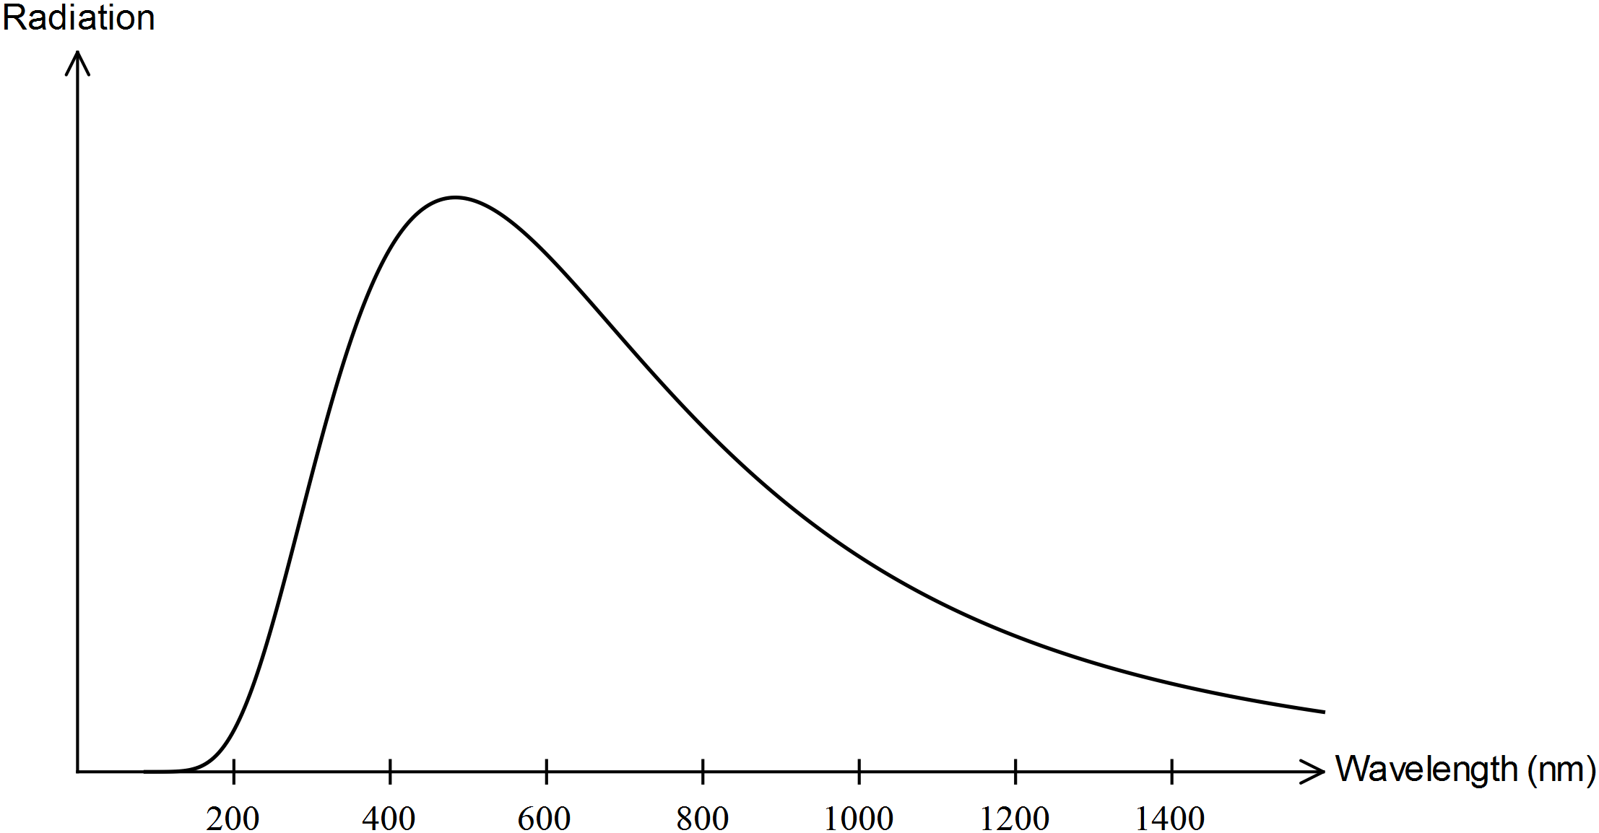

Visible light has a frequency range of approximately 4 × 1014 Hz to 8 × 1014 Hz.

1. Mark a band on the graph above showing the visible light emitted by an object at 4500 K. [2]
2. Add a curve to the diagram above showing the black body radiation for an object at 5000 K. [2]
3. For which part of the graph, very low wavelengths or very high wavelengths, does the graph above support both particle and wave natures for light? Why? [2]

**Question 5 (6 marks)**

1. State and explain one observation that can be made in a photoelectric effect experiment that demonstrates that light is quantized. [2]
2. Students recorded the results of a photoelectric effect experiment that used a copper plate. They produced the following line of best fit for their data:

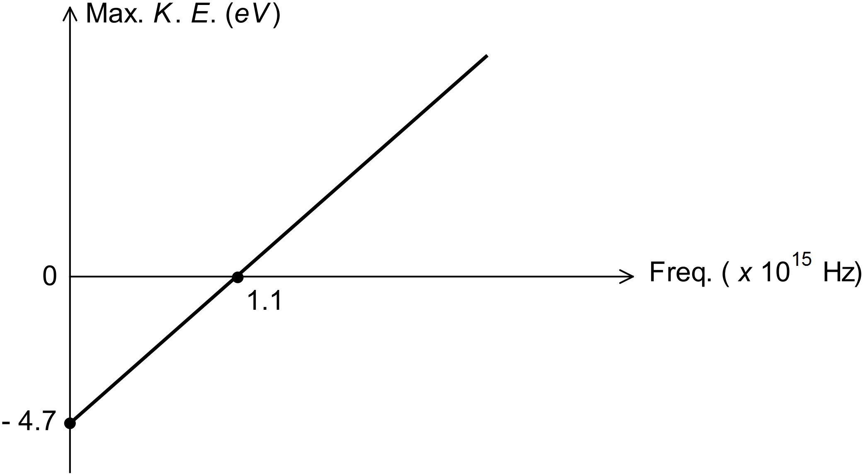

* 1. Use the graph to find the threshold frequency for copper (to 2 significant figures). [1]
  2. Use the graph to find the work function (in eV) for copper (to 2 significant figures). [1]
  3. Hence estimate the value of Planck’s constant. [2]

**Question 6 (10 marks)**

Electrons are accelerated from rest by a voltage of 10.5 V.

1. What is the energy of each electron in eV? [1]
2. Use the hydrogen energy level diagram below to determine the frequency of light emitted from ground state hydrogen atoms after they are bombarded by the accelerated electrons. [4]

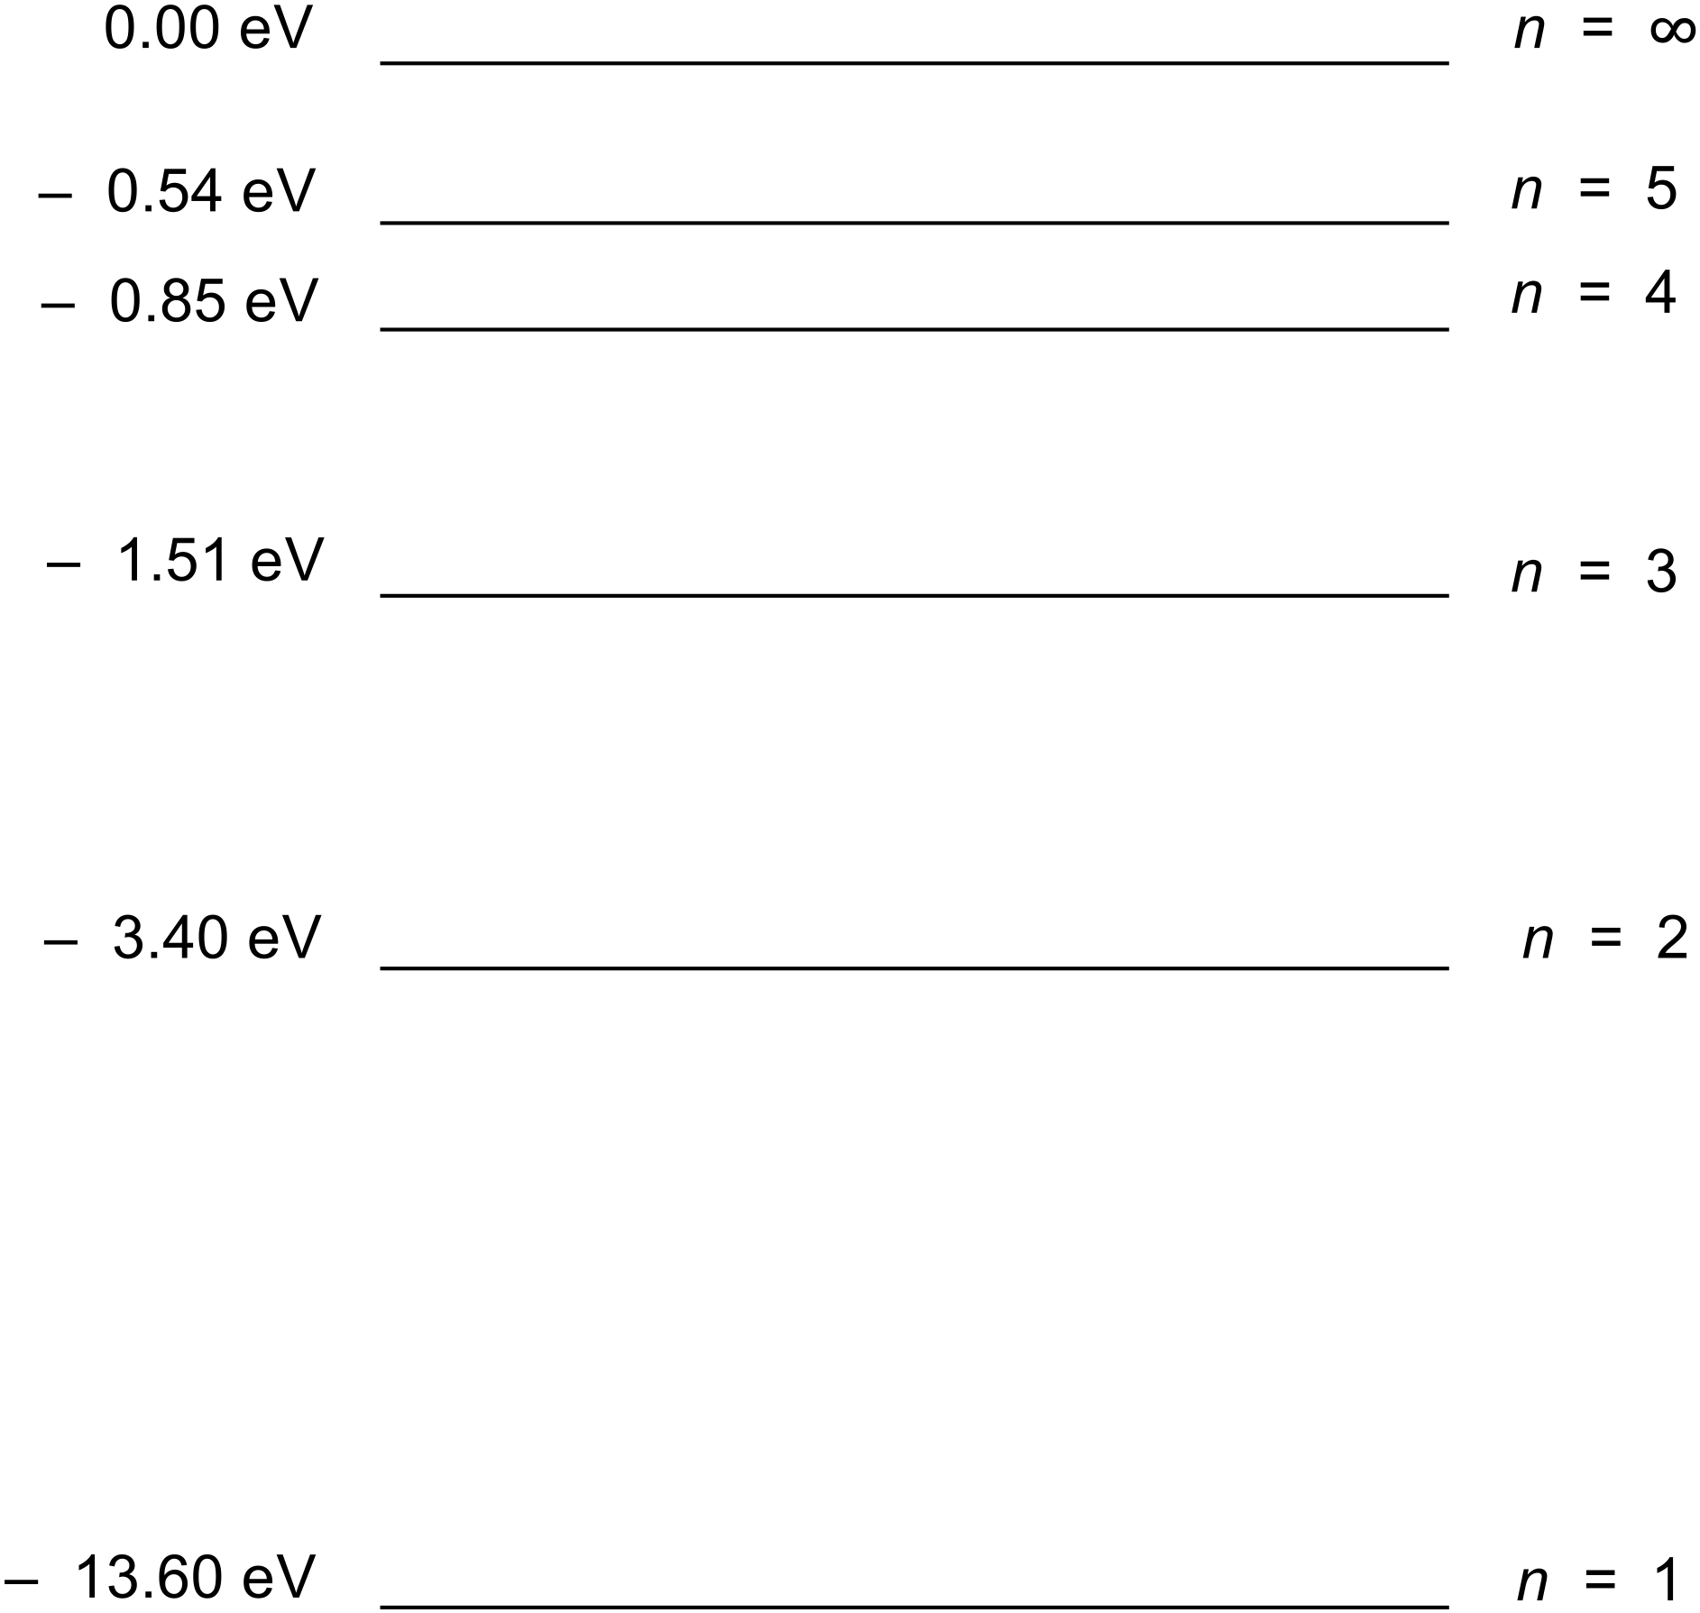

1. Find the de Broglie wavelength of the accelerated electrons. [5]

*- End of Questions -*